St Mary’s Voluntary Aided Primary School Nercwys

School Prospectus
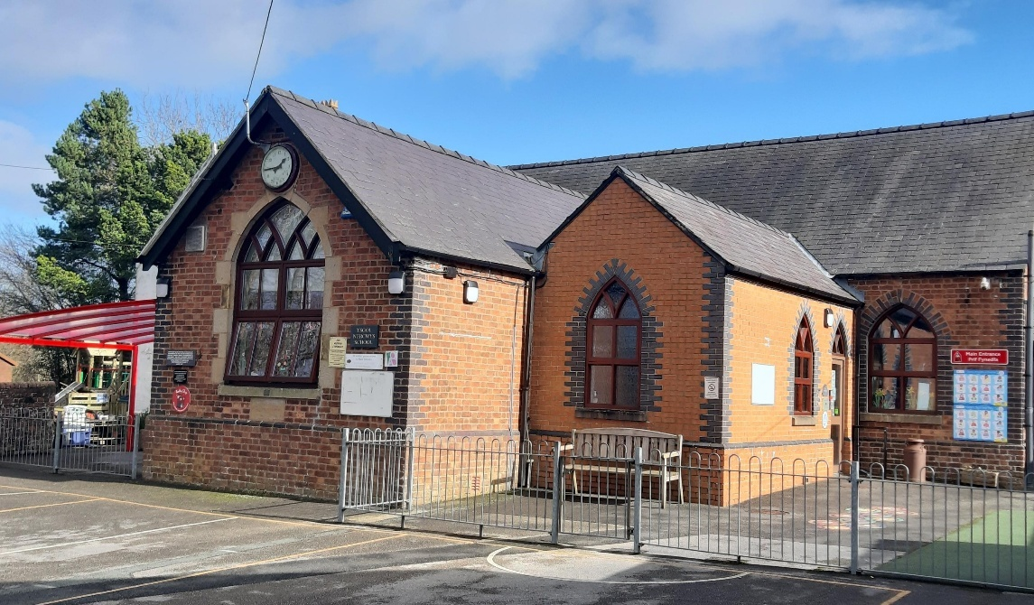

Challenging our Minds, Growing our Hearts
Herio ein Meddyliau, Tyfu ein Calonnau
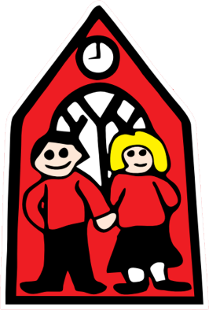
Part of The Nantlwys Federation
www.nantlwysfederation.com

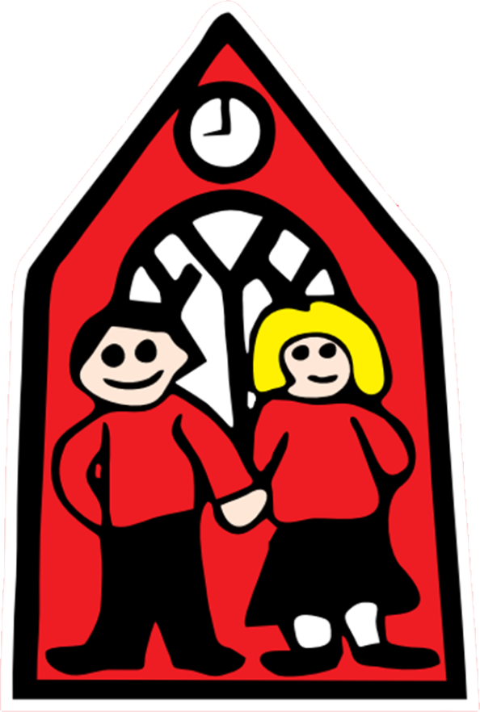Croeso/Welcome
Welcome to our prospectus.
I have been a governor at St Mary’s Nercwys for over 20 years and I was the Chair of Governors for St Mary’s before we federated with Ysgol Nannerch.
I have been Chair of governors for the Nantlwys Federation since April 2019. As a former pupil of Nercwys school I am proud to be involved with the school and the Federation. Within my own work role, I was the Senior Finance Lead in Wrexham Education Authority. This enables me to support our Federation to ensure our finances are managed effectively and efficiently.
I firmly believe that the Federation has been beneficial for both schools. Each school has kept all the qualities that we celebrate whist gaining extra skills and support from the other. We have a happy and successful Federation - schools who support each other to be successful.
The Governing Body are committed to providing the best possible learning experiences for each learner across the Federation, supporting them to fulfil their full potential and creating a nurturing family environment.
I hope that you will find this prospectus useful as an introduction to St Mary’s Nercwys and what the school can offer your child.

Mr. Ian Roberts
Chair of Governors
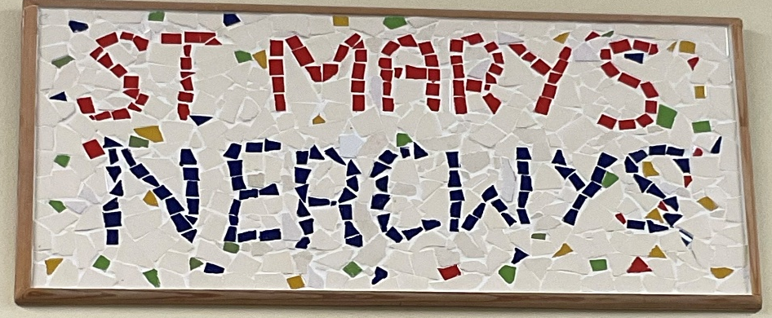
Headteacher Welcome
It gives me great pleasure to introduce you to St Mary’s, Nercwys with our latest prospectus.
What makes us special?
If you are looking for a small, nurturing school, set in beautiful countryside with a strong community feel then look no further! We aim to provide an enriching environment both inside and out which promotes every aspect of a child’s wellbeing. We are particularly proud of our extensive outdoor area, two school fields and creative teaching. We see our children thrive when learning outside in nature and take every opportunity for this to happen.

What are the benefits of a small school?
St Mary’s Nercwys was built in 1871 to serve the children of the village and surrounding areas. That means we are a purpose-built small bespoke setting and will always guarantee small class sizes. Our children all benefit from very high levels of adult support and guidance with learning experiences often tailored to children’s interests and needs. Every child counts at St Mary’s Nercwys, with leadership opportunities for all, no child is left behind or lost in the crowd.
What about mixed age classes?
Being taught in mixed ages means that our older children very quickly develop the key skills of leadership and empathy. They have excellent social skills as they often adapt to work with different personalities and ages. The younger children benefit from working alongside older role models. Mixed age teaching means that children are taught at the stage of development which is appropriate for them, ensuring both challenge and support is available at all times.
St Mary’s Nercwys has a longstanding tradition of educating children from Nercwys and the surrounding villages, dating back to 1871, I am proud to be continuing this excellent work as the current headteacher today.

Mrs Andrea Taylor
Headteacher
Our School
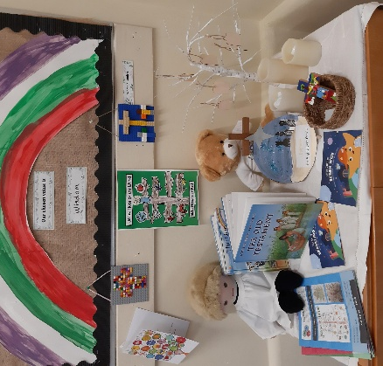
St Mary’s Nercwys is a Church in Wales Voluntary Aided Primary School with a proud heritage. Originally built in 1871 to serve the local community, it continues to flourish and is today a school of warmth, strength and vision. We are an English medium school who actively promotes Welsh as a second language.

Our school motto is
‘Challenging our Minds, Growing our Hearts’.
Our school’s values are:
Community Compassion Perseverance Trust Wisdom Hope
Our school has natural character and beauty. Nestled in the heart of the village community of Nercwys, St Mary’s Nercwys has a lovely location not far from Nercwys Forest in a designated Area of Outstanding Natural Beauty (AONB).
Respect and consideration for others permeates all aspects of school life, and our pupils are a credit to themselves, their families and their teachers with their outstanding behaviour.
Our school is a Voluntary Aided School within the Diocese of St Asaph. We liaise closely with the Diocese and Flintshire Education Authority. The school’s Admissions Policy is updated annually and available from the school office.
St Mary’s, Nercwys is proud to be part of the Nantlwys Federation. We are federated with Ysgol Nannerch, another small primary school near Mold. We are both rural Church schools and effectively support one another.
Our last inspection from Estyn was April 2023 and we were really pleased with the outcomes. The report is available online via Estyn or our own website.

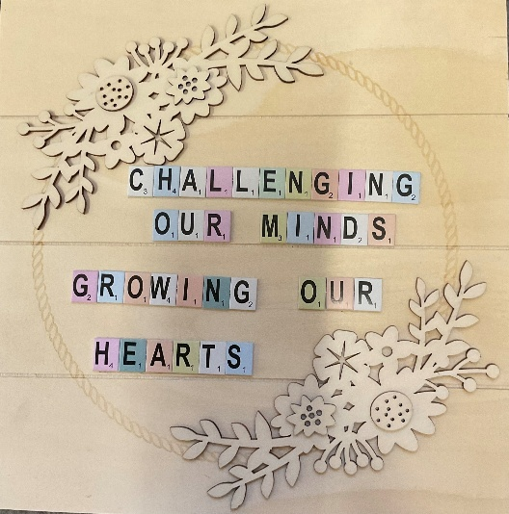
Our Vision
Challenging our Minds, Growing our Hearts
Herio ein Meddyliau, Tyfu ein Calonnau

At St Mary’s Nercwys we will be
'Challenging our Minds, Growing our Hearts'.
We will motivate everyone to do their very best and reach their full potential. Our nurture, care and support will ensure everyone will thrive at their own level yet challenged to be their best.
Our values are:
community compassion perseverance trust wisdom hope
- Learners will celebrate their Welsh language, heritage and culture throughout their school life
- Learners will be offered Outdoor learning
- Learners will receive purposeful and meaningful contexts to their learning which will build on Literacy, Numeracy and Digital skills in a fun and engaging curriculum.
- Learning will encompass the 4 purposes in exciting ways and teachers will ensure learners have all their individual needs met through a vibrant and fun curriculum.
- Learner voice is strong and this goes a long way in our topic planning, learner feedback and progress.
- Our school communities work closely with the wider community including St Mary’s Church, School Beat, local playgroups and nurseries and local businesses.
- Our topics and themes are built around ‘Cynefin’ Our Local areas and the natural environment, historical and geographical features which surround Nercwys.

Our Staff
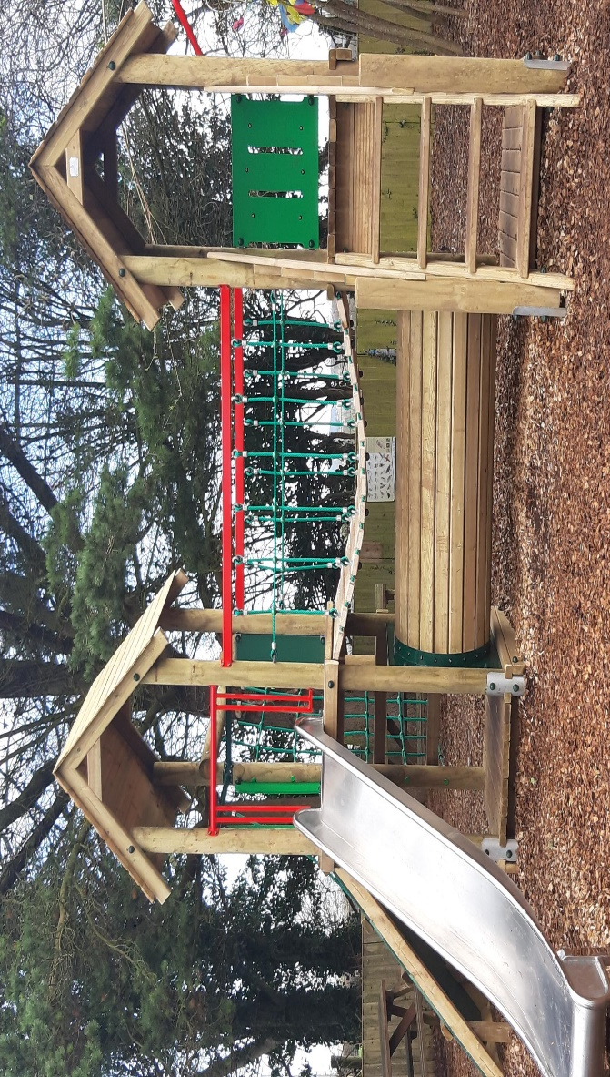
Headteacher | Mrs A Taylor
Deputy Headteacher | Miss J Roberts
ALNCo | Miss J Roberts
Foundation Phase Teacher | Mrs A Foster
KS2 Teacher | Mrs R Styles
HLTA | Mrs S Gibbons
Teaching Assistants | Mrs H Allen  Mrs J Elliott  Mrs S Hudson
Secretary | Mrs Fowles
Breakfast Club Supervisor | Mrs Elliott
Breakfast Club Assistants | Mrs Welsh
Mid-Day Supervisors | Mrs Elliott
After School Club Supervisors | Mrs Hudson  Mrs Polytska
After School Club Administrator | Mrs Fowles
Caretaker | Mr M Thomas

Governing Body
Working in close association with the Headteacher and Flintshire LA, the Governors have overall responsibility for school strategy and the efficient running of the school. Our governing body is made up of a committed, enthusiastic and talented group of people with diverse backgrounds who share a passion for the school and its place in the centre of our community.
The governors meet regularly as a full board, and also have a number of special sub-groups ensuring that close contact is maintained with the school covering staffing, curriculum and finance, for instance. As a full board, it represents all the groups who have an interest in the continuing success of the school: the local council, the church, the local authority, the staff and the parents. All our governors are approachable, and would be happy to explain their work more fully. Contact details are available from school. All meetings are recorded, and non-confidential minutes are available from school.

Name | Category
A Taylor | Headteacher
I Roberts (Chair of Governing Body) | Church foundation
C Yeardley (Deputy Chair of Governing Body) | Church foundation
Vacancy | Church foundation Nannerch
Rev K Stewart | Church ex-officio Nercwys
K Weston | Church foundation
K Bickerton | Community
J Roberts | Teacher (ALN)
J Downes | Local Authority
A Foster | Teacher
J Biddle | Parent
K Parry | Parent
Our School Day
Morning Session | 9.00am to 12.00pm
Lunchtime | 12.00pm to 1.00pm
Afternoon Sessions | 1.00pm to 3.15pm
Nursery sessions | 9:00am to 11:30am

Attending school regularly and punctually is very important. Should a child be absent, school should be informed by telephone, email or letter, before 9.30am on the first day of absence. This is when the registration period closes.
The reason for absence will always be required. ‘Authorised’ absences include:
• Illness
• Family holidays (up to a maximum of 10 days per year, and requiring the prior completion of a holiday form to ensure the permission of the headteacher)
• Medical/dental appointments
• Where LA-arranged transport to school does not arrive as planned

All other absences are recorded as ‘Unauthorised’ this includes persistent lateness and late arrivals after 9:30am
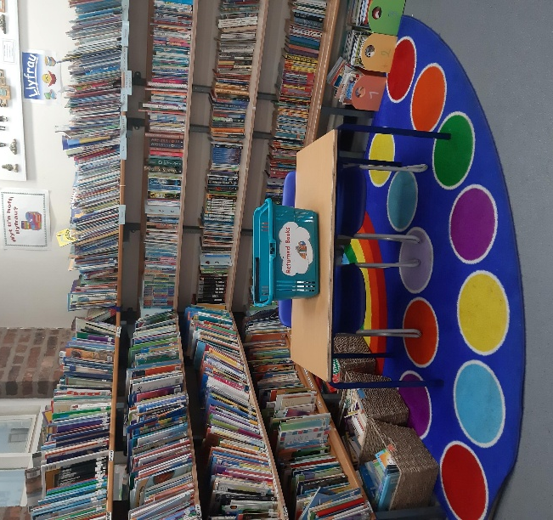
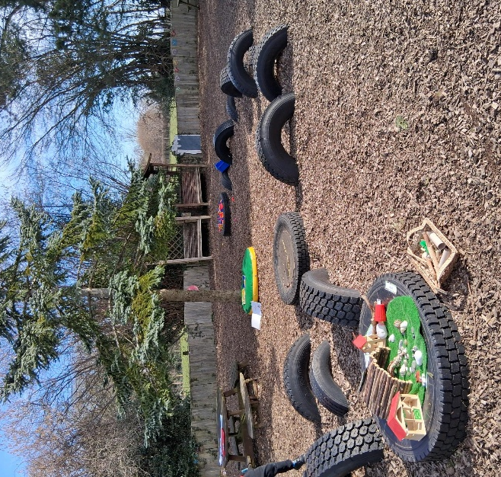

Wrap Around Care
Breakfast Club: We have a free Breakfast Club, which is funded by the Welsh Government. The Club is open to all school children including Nursery and Early Entitlement pupils.

The Club opens at 8.00 am for childcare with the free Breakfast club starting at 8:10am. There is a selection of cereal, toast, fruit, yoghurt. Breakfast Club are unable to admit children for 10 minutes, 8.40am – 8.50am, as this allows staff time to tidy up before the end of the session. I would like to ask parents that children arrive between 8.10am and 8.40am for Breakfast Club, or between 8.50am and 9am for the start of the school day, when teachers take legal responsibility for the pupils.
Please note that we can offer Wrap around care from 8am, but the first 10 minutes are not funded and do need to be paid for.
After School Club: We offer an onsite after school club until 5pm. The charges are:
3:15pm–4:30pm – £6.50
3:15pm–5:00pm – £9.00
Themed nights (including food) – £10.00

School Communication
We provide ongoing information to ensure that parents feel informed about their school and their child’s education. We use Seesaw to share what children have been learning about in class.
The Nantlwys Federation facebook page is updated regularly.

We use “SchoolComms”, a text-messaging service to parents.

We hold regular ‘Welcome Wednesdays’ and workshops throughout the school year. These provide opportunities for families to come into school to see the children’s work, speak to staff and keep up to date with new developments.
Staff/Parent Contact Time
You are more than welcome to see your child’s teacher at the end of the school day. Alternatively, you can arrange with the child’s class teacher an appointment.
We report progress to parents during each school term. The Autumn term provides an opportunity for parents to meet their child’s teacher/s and receive information about their child’s progress, targets and the planned work for the year. During the Spring term we provide a structured parent’s evening to discuss children’s work, targets and progress. In the Summer term, parents are provided with a written report on their child’s progress and are then invited to request a follow-up meeting with their teacher if required.

School Meals and Snacks
We are very fortunate at St Mary’s Nercwys VA to have good school lunches prepared by Newydd. There are usually two choices daily, with the additional availability of jacket potatoes, pasta pots or packed lunches.
All primary school pupils from Reception to Year 6 in Wales receive free school lunch.
Children are welcome to bring their own packed lunches to school. As a Healthy School, we ask that parents consider healthy options for their child.
Fruit snacks are offered at mid-morning break, with parents contributing towards the cost payable each half term. Foundation Phase pupils are also offered a free drink of milk. Pupils are asked to bring in their own water bottle which can be topped up during the day with water. We would again encourage parents to assist their child in making healthy choices.
Families on low income can get help with School Essentials – search: Flintshire Free School Meals (eFSM) and School Essentials Grant

Admissions
We follow Flintshire’s ‘Policy, Procedures and Process for Admissions to Schools’, although, as we are a Voluntary Aided Church School, our Governing Body oversees admissions.
If, by 31st August, your child has reached their 3rd birthday, they can attend five ½ day ‘nursery’ sessions each week from September. Parents can apply to their preferred school and all schools have a maximum admission number for each year group. We also participate in Flintshire’s ‘Early Entitlement’ Scheme, where children are able to attend school for our morning nursery sessions during the Spring and / or Summer school terms following their 3rd birthday.
If, by 31st August, your child has reached their 4th birthday, they can begin their full-time education - their ‘Reception’ year - at school in September.
Although most children start school at the beginning of an academic year, some may move during the school year for various reasons. We welcome new starters to our school provided our class numbers allow and in accordance with Flintshire County Council Guidelines.
We always welcome the opportunity to meet and present our school to families. Our headteacher would be happy to arrange a mutually convenient time to meet.
For further information regarding the County’s Admission Policy, details can be provided by school, or on our website www.nantlwysfederation.com
Inclusion
St Mary’s Nercwys VA is determined to demonstrate the advantages to all in providing a truly inclusive school community. We strongly believe that every child can achieve and will strive to do their best within an environment which promotes every aspect of their wellbeing.
We believe in the principles of diversity and equality. This does not mean we treat everyone the same, but that we recognise and respect difference and tackle barriers that cause discrimination. Every family is different; we celebrate individuality and encourage each child to reach their unique potential. Differences include gender, culture, disability, age, religion and language ethnicity. We strive to develop understanding of these differences so that we can meet the needs of our whole community. We are able to accommodate wheelchairs, and have a disabled toilet. All teaching is accessible on the ground floor, and outdoor learning environments are accessible.

Health and Well-being
We take the health, safety and security of our pupils, staff and premises seriously at St Mary’s Nercwys. We aim to provide an environment that is safety conscious but not one that suppresses children’s development of their own sense of responsibility for themselves and others.
School doors and gates are kept locked and all visitors must ring the bell and wait for a member of staff to open the door. Pupils who are late should enter via the school office entrance and sign in.
At St Mary’s Nercwys, we believe that all staff and pupils have the right to be respected, to feel safe, to be listened to and to learn. These form the basis of our school rules. We have many positive ways of promoting and good behaviour. At St Mary’s Nercwys we expect good behaviour and acknowledge and reward behaviour that goes ‘above and beyond’. The children have created their own behaviour policy with agreed sanctions and rewards. A full copy of this is available from the school office.

Curriculum
At St Mary’s Nercwys, we passionately believe that learning should be engaging and inspiring and should support all our children to develop as:
- Ambitious and capable learners
- Creative and enterprising contributors
- Ethical informed citizens
- Healthy and confident individuals
We provide a broad, balanced curriculum such that the talents and interests of all of our children can be recognised and developed. Each term across all age groups, there is a topic or theme through which much of the learning is organised. This encourages ownership, develops children’s independence and shows that everything we do has a purpose - enabling us to celebrate children’s work in meaningful ways.
Our curriculum encompasses all six areas of learning and experience as well as literacy, numeracy and digital skills which are taken across into other curriculum areas. The six areas of learning and experiences are:
- Health and Wellbeing
- Expressive Arts
- Humanities
- Language, Literacy and Communication
- Mathematics and Numeracy
- Science and Technology

Relationships and Sexuality Education
The Government and Flintshire LA provide guidance on how schools should cover this important area in a child’s development. Particularly, they state that Relationships and Sexuality Education should not be provided in isolation, but included through the Six Areas of Learning and Experience. It is a mandatory part of the curriculum and taught in a developmentally appropriate way. It is crucial that children develop a sound understanding of their and others’ development, allowing them to mature emotionally with healthy attitudes towards people and relationships.
Bilingualism
St Mary’s Nercwys teaches Welsh as a second language. Living and learning in Wales, we are keen to encourage the development of the Welsh language for our pupils, their families and our staff. We aim to use incidental Welsh as frequently as possible throughout the school day, in addition to structured teaching in Welsh lessons. We reinforce the value of Welsh all around the school, for example through the ‘Criw Cymraeg’. St Mary’s school has been awarded the Bronze Award in recognition of our commitment to the Welsh language.

Religion, Values and Ethics
As a Church in Wales Voluntary Aided School, we are proud of our strong links with the village church, St Mary’s, and the church community. This link directly contributes to our school’s Christian ethos and to the children’s spiritual, moral and social development.
We hold regular whole-school worship, as well as participating in events such as ‘Open the Book’. We conduct a number of services at our village church, including Harvest Festival and our Christmas Carol Service. These activities directly develop children’s skills of speaking and listening as well as contributing towards becoming confident individuals. RVE is a mandatory part of the curriculum and we teach religious and non-religious and philosophical convictions through our humanities lessons.

Matters of Concern
Should any parent have a specific question or concern, then our teaching staff or headteacher would welcome discussing this quickly and will always make themselves available at a mutually convenient time.
We have a formal policy for dealing with complaints which is reviewed regularly by the Governing Body and is available from the school office, if required.
Safeguarding and Child Protection
The Department for Education and Welsh Office Guidelines make it clear that schools and colleges have important roles to play in the protection of children against abuse. This is confirmed by the Policy of Flintshire County Council, which sets out the necessary procedures to be followed by all staff. St Mary’s Nercwys, therefore has a duty to refer any concerns about the well-being of pupils to the Social Services Department. The Headteacher, and Deputy Headteacher are the safeguarding leads for St Mary’s Nercwys.

Additional Learning Needs
We have a team of trained practitioners including Teaching Assistants who confidently and successfully deliver a wide range of strategies to support all learners in 1:1, small group and within an inclusive class setting. Our Additional Learning Needs Coordinator (ALNCo), Miss Roberts, and the class teachers oversee the structured support provided across the whole school.
Our highly skilled staff develop strong relationships with all the children, and are quickly able to notice if anyone needs extra learning support including those needing additional challenge. For those children who require support with emotional literacy, self-esteem, social skills and friendship issues, we have staff trained in ELSA.

The Nurture room at St Mary’s

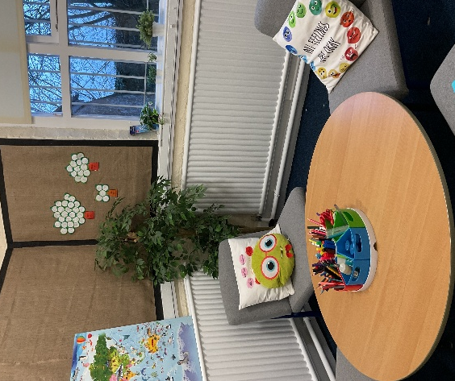
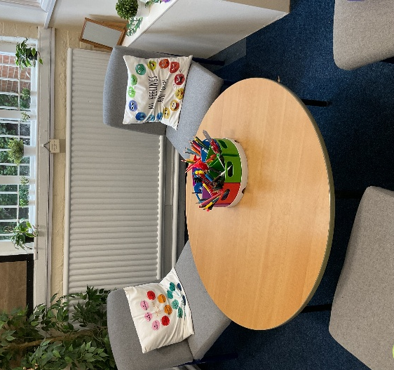


Uniform
We encourage all our children to wear our smart and practical uniform at St Mary’s Nercwys. Our school colours are red and black. The items in bold in the list below include our school logo, and are ordered through Forrester by Monkhouse, Mold and the Craft shack throughout the academic year. Other items are widely available locally at reasonable prices.
Warmer Months | Colder Months | PE and Outdoors
• Red polo shirt  • Red sweatshirt  • Red cardigan  • Black shorts/trousers  • Red gingham summer dress  • ‘School’ shoes | • Red polo shirt  • Red sweatshirt  • Red cardigan  • Black trousers  • Black or Grey skirt, pinafore or trousers  • ‘School’ shoes or boots | - White T-shirt  - Black jogging bottoms or shorts  - Red zip-up track suit top or fleece  - Trainers

All items of clothing should be clearly marked with the child’s name. Both Foundation Phase and KS2 are encouraged to wear P.E. Uniform on PE and outdoor days. Waterproofs and wellies may be left in school for wet weather days.
We strongly discourage the wearing of jewellery in school. Children with pierced ears should only wear small studs to school, and school cannot be held responsible for the loss or damage of such items. Smart watches are not permitted.

Contact Details
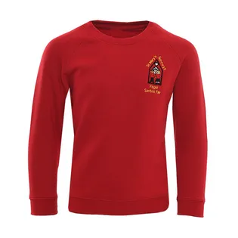
Nercwys Primary School
Ffordd Pen y Bryn
Nercwys
Mold
Flintshire
CH7 4EL

Telephone: 01352 752654

e-mail: nemail@hwbcymru.net

website: www.nantlwysfederation.com

