Ysgol Nannerch Voluntary Controlled Primary School
School Prospectus
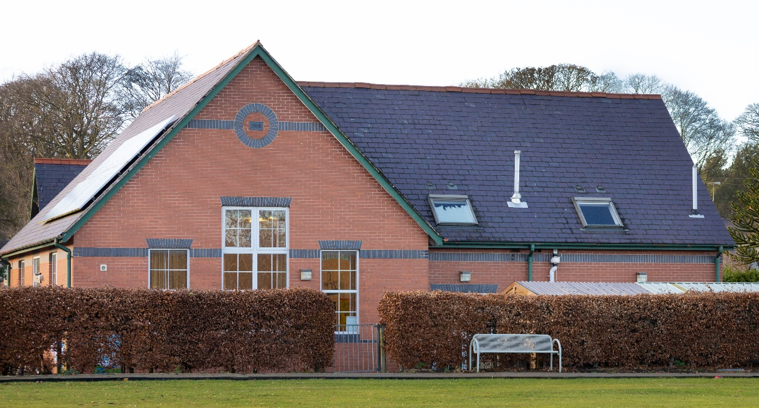

Challenging our Minds, Growing our Hearts
Herio ein Meddyliau, Tyfu ein Calonnau

Part of The Nantlwys Federation
www.nantlwysfederation.com
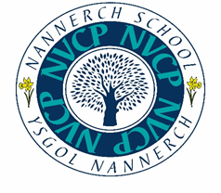
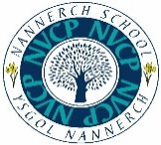
Croeso/Welcome

Welcome to our new prospectus.
I have been a Governor at St Mary’s Nercwys for over 20 years and I was the Chair of Governors for St Mary’s before we federated with Ysgol Nannerch.
I have been Chair of Governors for the Nantlwys Federation since April 2019. As a former pupil of Nercwys school I am proud to be involved with the Federation. Within my own work role, I was the Senior Finance Lead in Wrexham Education Authority. This enables me to support our Federation to ensure our finances are managed effectively and efficiently.
I firmly believe that the Federation has been beneficial for both schools. Each school has kept all the qualities that we celebrate whist gaining extra skills and support from the other. We have a happy and successful Federation - schools who support each other to be successful.
The Governing Body are committed to providing the best possible learning experiences for each learner across the Federation, supporting them to fulfil their full potential and creating a nurturing family environment.
I hope that you will find this prospectus useful as an introduction to St Mary’s Nercwys and what the school can offer your child.

Mr. Ian Roberts
Chair of Governors
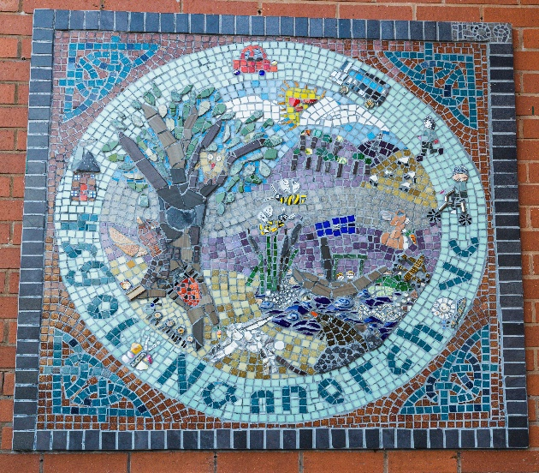

Croeso/Welcome

It gives me great pleasure to introduce you to Ysgol Nannerch with our latest prospectus.
What makes us special?
If you are looking for a vibrant village school, set in beautiful countryside with a strong community feel then look no further! We aim to provide an enriching environment both inside and out which promotes every aspect of a child’s wellbeing. We are particularly proud of our extensive outdoor area, Christian ethos and creative teaching. Church schools are inclusive by nature, welcoming children from families of all faiths and none, while recognising that faith is something that shapes people’s lives.
What are the benefits of a small school?
Ysgol Nannerch was built in 1891 to serve the children of the village and surrounding areas. That means we can guarantee small class sizes with very high levels of adult support and guidance. Our experienced staff tailor learning experiences to children’s interests and needs. Every child counts with leadership opportunities for all, no child is left behind or lost in the crowd.
What about mixed age classes?
Being taught in mixed ages means that our older children very quickly develop the key skills of leadership and empathy. They have excellent social skills as they often adapt to work with different personalities and ages. The younger children benefit from working alongside older role models. Mixed age teaching means that children are taught at the stage of development which is appropriate for them, ensuring both challenge and support is available at all times rather than a narrow curriculum prescribed only to suit one age group at a time.
Ysgol Nannerch has a longstanding tradition of educating children from Nannerch and the surrounding villages, dating back to 1891, I am proud to be continuing this excellent work as the current headteacher today.
Mrs Andrea Taylor
Headteacher
Our School

Ysgol Nannerch is a Church in Wales Voluntary Controlled Primary School with a proud heritage. Originally built in 1891 to serve the local community, it continues to flourish and is today a school of warmth, strength and vision. We are an English medium school who actively promotes Welsh as a second language.
Our school motto is
‘Challenging our Minds, Growing our Hearts’.
Our school’s values are:
Community Compassion Perseverance Trust Wisdom Hope
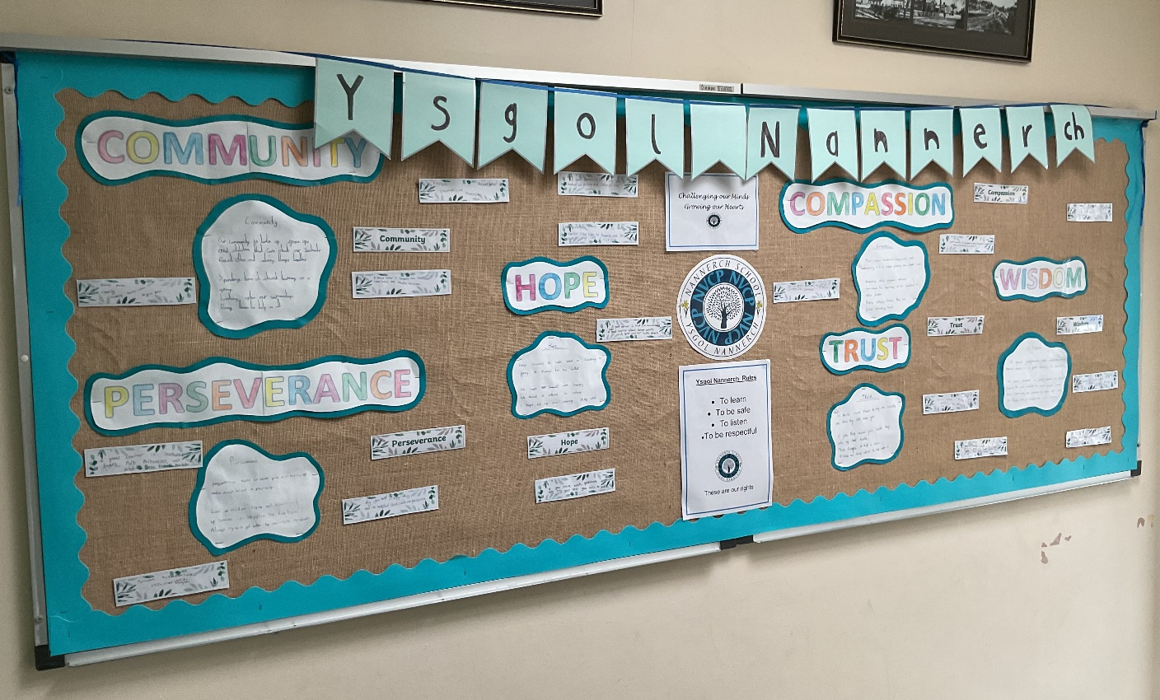

Our school has natural character and beauty. Following small additions to the original Victorian building, a sympathetic extension was completed in 1998 adding modernity with flexible and creative accommodation. Nestled in the heart of the thriving village community of Nannerch, in a designated Area of Outstanding Natural Beauty (AONB), Ysgol Nannerch boasts an enviable location.

Our outdoor learning and play environments are extensive - including a multi-purpose hard surface court, junior football pitch that all benefit from an uninterrupted outlook of our inspiring surrounding countryside.
Our school is a Voluntary Controlled School within the Diocese of St Asaph. We liaise closely with the Diocese and Flintshire Education Authority. The school’s Admissions Policy is updated annually and available from the school office.
Ysgol Nannerch is proud to be part of the Nantlwys Federation. We are federated with St Mary’s Nercwys, another small primary school near Mold. We are both rural Church schools and effectively support one another.
Our last inspection from Estyn was April 2023 and we were really pleased with the outcomes. The report is available online via Estyn or our own website.
We are a small school of around 30 full-time pupils. We place great emphasis on maintaining a very favourable teacher: pupil ratio. We use our teachers’ skills and expertise together with our dedicated classroom support staff to develop strong relationships with the children and a clear idea of their needs and abilities. Respect and consideration for others permeates all aspects of school life, and our pupils are a credit to themselves, their families and their teachers with their outstanding behaviour.

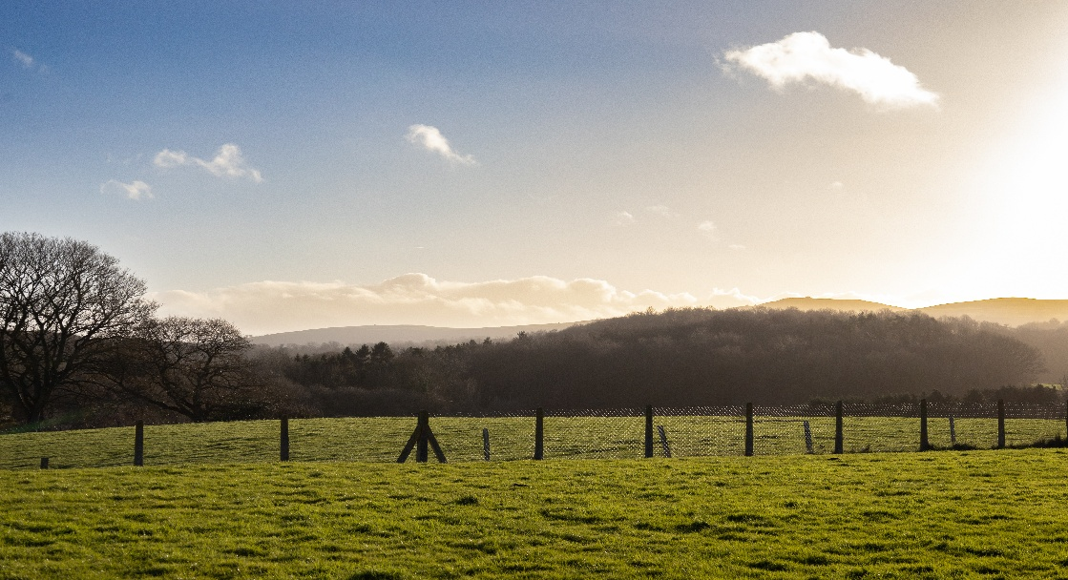

Our Vision

Challenging our Minds, Growing our Hearts
Herio ein Meddyliau, Tyfu ein Calonnau

In the Nantlwys Federation we will be 'Challenging our Minds, Growing our Hearts'. We will motivate everyone to do their very best and reach their full potential. Our nurture, care and support will ensure everyone will thrive at their own level yet challenged to be their best.

Our values are:
community compassion perseverance trust wisdom hope
- Learners will celebrate their Welsh language, heritage and culture throughout their school life
- Learners will be offered Outdoor learning and Forest School
- Learners will receive purposeful and meaningful contexts to their learning which will build on Literacy, Numeracy and Digital skills in a fun and engaging curriculum.
- Learning will encompass the 4 purposes in exciting ways and teachers will ensure learners have all their individual needs met through a vibrant and fun curriculum.
- Learner voice is strong and this goes a long way in our topic planning, learner feedback and progress.
- Our school communities work closely with the wider community including Church, School Beat, local playgroups and nurseries and local businesses.
- Our topics and themes are built around ‘Cynefin’ Our Local areas and the natural environment, historical and geographical features which surround Nannerch.

Our Staff

Headteacher | Mrs. A Taylor
Deputy Headteacher and ALNCo | Miss J Roberts
KS2 Teacher | Miss J Roberts
Foundation Phase Teacher | Mrs H Gunes
Teaching Assistants | Mrs G Raynor  Miss S Cox  Mr I Lewis  Mrs S Gibbons  Miss E Douggie
Secretary | Mrs. C Fowles
Cook-In-Charge | Newydd
Caretaker | Mr. B Mead
Mid-Day Supervisors | Mrs. S Cox  Mr I Lewis  Mrs G Raynor
Breakfast Club | Mr I Lewis

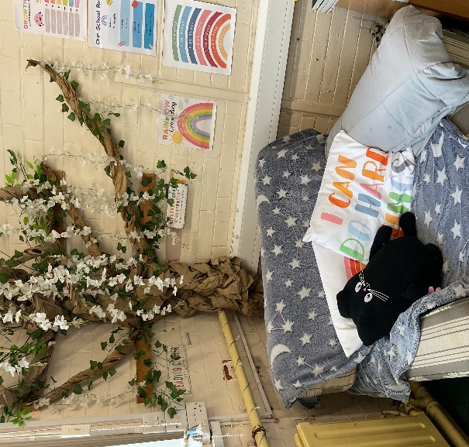

Governing Body

Working in close association with the Headteacher and Flintshire LA, the Governors have overall responsibility for school strategy and the efficient running of the school. Our governing body is made up of a committed, enthusiastic and talented group of people with diverse backgrounds who share a passion for the school and its place in the centre of our community.
The governors meet regularly as a full board, and also have a number of special sub-groups ensuring that close contact is maintained with the school covering staffing, curriculum and finance, for instance. As a full board, it represents all the groups who have an interest in the continuing success of the school: the local council, the church, the local authority, the staff and the parents. All our governors are approachable, and would be happy to explain their work more fully. Contact details are available from school. All meetings are recorded, and non-confidential minutes are available from school.
Name | Category
A Taylor | Headteacher
I Roberts (Chair of Governing Body) | Church foundation
C Yeardley (Deputy Chair of Governing Body) | Church foundation
Rev K Stewart | Church ex-officio
K Weston | Church foundation
K Bickerton | Community
Miss J Roberts | Teacher - ALN
Mrs J Downes | Local Authority
Mrs A Foster | Teacher
J Biddle | Parent
K Parry | Parent

Our School Day

Hours of Attendance
Morning Session | 8.50am to 12.00pm
Lunch and Mid-day break | 12.05pm to 12:50pm KS2  12:00pm to 1:00pm Foundation
Afternoon Session | 12.50pm to 3.00pm  1:00pm to 3:00pm
Nursery Sessions | 12.45pm to 3:00pm

Attending school regularly and punctually is very important.
Should a child be absent, school should be informed by telephone, email or letter, before 9.20am on the first day of absence. This is when the registration period closes, and when information is required by the school cook for lunch preparation.

The reason for absence will always be required. ‘Authorised’ absences include:
• Illness
• Family holidays (up to a maximum of 10 days per year, and requiring the prior completion of a holiday form to ensure the permission of the headteacher)
• Medical/dental appointments
• Where LA-arranged transport to school does not arrive as planned

All other absences are recorded as ‘unauthorised’ this includes persistent lateness and arrivals after close of registration.

Wrap Around Care


Before and After School Club

The Den after school club and breakfast club are available to nursery and school children over 3 years of age.

The Den, Afterschool Club is managed independently of school but school and club work alongside each other in offering quality childcare, fun activities and out-of-hours learning. It is legally constituted and officially registered with the Care Inspectorate Wales.

A variety of indoor and outdoor activities are on offer, and individuals or groups are regularly invited to provide particular activity sessions – for example, the children have enjoyed ‘Cookery Club’ Yoga and tennis workshops.

Club Charges and Opening Times (subject to change; information available via school office).
Before School Club:
8.00am – 8:10 am £2:00
8:10-8:40am Free including Breakfast. Last admittance to breakfast club is 8:30 to allow time for children to eat breakfast.

After School Club:
End of school – 5:30pm £12

Due to the costs involved in keeping the school open later than planned in the evening, a £10 (per child) late collection charge has to be made.

Nannerch Under 5’s Playgroup
We run a walking bus between school and Nannerch Under 5’s Playgroup situated in the village hall. We have strong working relationships with the playgroup. We offer Early Entitlement at school meaning that children aged 3 can access full day care from 8:00am until 5:30pm in conjunction with the playgroup.

Staff/Parent Contact Time

You are more than welcome to see your child’s teacher at the end of the school day. Alternatively, you can arrange an appointment with the child’s class teacher.
We report progress to parents during each school term. The Autumn and Spring terms provide opportunities for parents to meet their child’s teacher/s and receive information about their child’s progress and targets. In the Summer term, parents are provided with a written report on their child’s progress and are then invited to request a follow-up meeting with their teacher if required.

School Communication
We provide ongoing information to ensure that parents feel informed about their school and their child’s education. We use Seesaw to share what children have been learning about in class.
The Ysgol Nannerch facebook page is updated regularly.

We use “SchoolComms”, a text-messaging service to parents.

We hold regular ‘Welcome Wednesdays’ and workshops throughout the school year. These provide opportunities for families to come into school to see the children’s work, speak to staff and keep up to date with new developments.
Our school website also holds useful information and documents
.

School Meals and Snacks

We are very fortunate at Ysgol Nannerch to have good school lunches prepared by Newydd. There are usually two choices daily, always with the additional availability of salad items, and ‘specials’ are created throughout the weeks.
All primary school pupils from Reception to Year 6 receive free school meals.
Families on low income can get help with School Essentials – search: Flintshire Free School Meals (eFSM) and School Essentials Grant
Children are welcome to bring their own packed lunches to school. As a Healthy School, we ask that parents consider healthy options for their child.
Snacks are encouraged during mid-morning break. Foundation Phase and KS2 are provided with a healthy snack and a drink of milk with parents contributing £1.25 per week. This is payable at the start of each week. KS2 are also free to bring a snack and water, and we would again encourage parents to assist their child in making healthy choices.

Starting School at Ysgol Nannerch

We follow Flintshire’s ‘Policy, Procedures and Process for Admissions to Schools’.
If, by 31st August, your child has reached their 3rd birthday, they can attend five ½ day ‘nursery’ sessions each week from September. Parents can apply to their preferred school and all schools have a maximum admission number for each year group. Ysgol Nannerch can accept up to 15 children in each year group.
We also participate in Flintshire’s ‘Early Entitlement’ Scheme, where children are able to attend school for our afternoon nursery sessions during the 1 or 2 school terms following their 3rd birthday.
If, by 31st August, your child has reached their 4th birthday, they can begin their full-time education - their ‘Reception’ year - at school in September.
Although most children start school at the beginning of an academic year, some may move during the school year for various reasons. We welcome new starters to our school provided our class numbers allow and in accordance with Flintshire County Council Guidelines.
We always welcome the opportunity to meet and present our school to families. Our headteacher would be happy to arrange a mutually convenient time to meet if contacted directly, and we also aim to arrange ‘Open Days’ for our local playgroups and others as regularly as possible.
For further information regarding the County’s Admission Policy, details can be provided by school, or Flintshire’s Primary Schools Officer on 01352 704019.
Inclusion
Ysgol Nannerch is determined to demonstrate the advantages to all in providing a truly inclusive school community. We strongly believe that every child can achieve and will strive to do their best within an environment which promotes every aspect of their wellbeing.
We believe in the principles of diversity and equality. This does not mean we treat everyone the same, but that we recognise and respect difference and tackle barriers that cause discrimination. Every family is different; we celebrate individuality and encourage each child to reach their unique potential. Differences include gender, culture, disability, age, religion and language ethnicity. We strive to develop understanding of these differences so that we can meet the needs of our whole community. We are able to accommodate wheelchairs, and have a disabled toilet. All teaching is accessible on the ground floor, and outdoor learning environments are accessible.

Health and Wellbeing

We take the health, safety and security of our pupils, staff and premises seriously at Ysgol Nannerch. We aim to provide an environment that is safety conscious but not one that suppresses children’s development of their own sense of responsibility for themselves and others.
School doors and gates are kept locked and all visitors must ring the bell and wait for a member of staff to open the door. Pupils who are late should enter via the school office entrance and sign in.

Behaviour and Rules
At Ysgol Nannerch we have the following rules devised by the children and based on their rights:

Ysgol Nannerch Rules
· To listen
· To learn ·
· To be safe
· To be respectful

We expect all children to behave well but ‘above and beyond’ behaviour is acknowledged and rewarded. This is done through earning ‘Star in a Jar’. Each star equates to 3 minutes of reward time. Each class has a jar and all stars are counted and taken as a whole class reward. Any staff member can award a star and once earnt, no star can be withdrawn.

Misbehaviour will be dealt with immediately by following the agreed policy with sanctions developed alongside our children.
If a child is involved in a high-level behavioural incident parents may be invited into school to discuss this with the Headteacher.
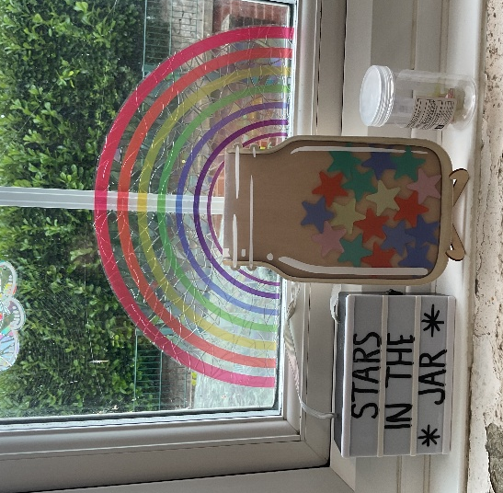

Curriculum

At Ysgol Nannerch, we passionately believe that learning should be engaging and inspiring and should support all our children to develop as:
- Ambitious and capable learners
- Creative and enterprising contributors
- Ethical informed citizens
- Healthy and confident individuals
We provide a broad, balanced curriculum such that the talents and interests of all of our children can be recognised and developed. Each term across all age groups, there is a topic or theme through which much of the learning is organised. This encourages ownership, develops children’s independence and shows that everything we do has a purpose - enabling us to celebrate children’s work in meaningful ways.
Our curriculum encompasses all six areas of learning and experience as well as literacy, numeracy and digital skills which are taken across into other curriculum areas. The six areas of learning and experiences are:
- Health and Wellbeing
- Expressive Arts
- Humanities
- Language, Literacy and Communication
- Mathematics and Numeracy
- Science and Technology
Relationships and Sexuality Education
The Government and Flintshire LA provide guidance on how schools should cover this important area in a child’s development. Particularly, they state that Relationships and Sexuality Education should not be provided in isolation, but included through the Six Areas of Learning and Expertise. It is a crucial area of development, and it is important to respond to children’s natural curiosity. This enables them to develop a sound understanding of their and others’ development, allowing them to mature emotionally with healthy attitudes towards people and relationships.
Bilingualism
Ysgol Nannerch teaches Welsh as a second language. Living and learning in Wales, we are keen to encourage the development of the Welsh language for our pupils, their families and our staff. We aim to use incidental Welsh as frequently as possible throughout the school day, in addition to structured teaching in Welsh lessons. We reinforce the value of Welsh all around the school. We have a Criw Cymraeg who are advocates for Cymraeg Campus. Ysgol Nannerch holds the bronze award.

Religion, Values and Ethics
As a Church in Wales Voluntary Controlled School, we are proud of our strong links with the village church, St Michaels and All Angels, and church community. This link directly contributes to our school’s ethos and atmosphere and to the children’s spiritual, moral and social development.
We hold regular whole-school worship, as well as participating in events such as ‘Open the Book’. We conduct a number of services at our village church, including Harvest Festival and our Christmas Carol Service. RVE is a mandatory part of the curriculum and we teach religious and non-religious and philosophical convictions through our humanities lessons.

Matters of Concern
Should any parent have a specific question or concern, then our teaching staff or headteacher would welcome discussing this quickly and will always make themselves available at a mutually convenient time.
We have a formal policy for dealing with complaints which is reviewed regularly by the Governing Body and is available the from the school office if required.

Safeguarding and Child Protection

The Department for Education and Welsh Office Guidelines make it clear that schools and colleges have important roles to play in the protection of children against abuse. This is confirmed by the Policy of Flintshire County Council, which sets out the necessary procedures to be followed by all staff. Ysgol Nannech, therefore has a duty to refer any concerns about the well-being of pupils to the Social Services Department. The Headteacher, and Deputy Headteacher are the safeguarding leads for Ysgol Nannerch.

Additional Learning Needs
We have a team of trained practitioners including Teaching Assistants who confidently and successfully deliver a wide range of strategies to support all learners in 1:1, small group and within an inclusive class setting. Our Additional Learning Needs Coordinator (ALNCo), Miss Roberts, and the class teachers oversee the structured support provided across the whole school.
Our highly skilled staff develop strong relationships with all the children, and are quickly able to notice if anyone needs extra learning support including those needing additional challenge. For those children who require support with emotional literacy, self-esteem, social skills and friendship issues, we have staff trained in ELSA.

Uniform

Our school colours are jade and navy blue. The items in bold in the list below include our school logo, and are ordered through Forrester by Monkhouse, Mold or the Craft Shack in Mold, throughout the academic year. Other items are widely available locally at reasonable prices.
Warmer months | Colder months | PE / Outdoor
- Navy short trousers  - Navy polo shirt  - Jade/navy gingham summer dress  - Jade cardigan  - ‘School’ shoes | - Navy polo shirt  - Jade sweatshirt  - Jade cardigan  - Navy skirt, pinafore or trousers  - ‘School’ shoes or boots | - Jade T-shirt  - Navy tracksuit bottoms, shorts or leggings  - School hoody, fleece or sweatshirt

Both Foundation Phase and KS2 are encouraged to wear P.E. Uniform. We take part in a number of sporting activities away from the school during these years, and it is important that our pupils can be easily recognised. This consists of navy shorts/tracksuit bottoms, and a jade P.E. t-shirt. When other sportswear is required by the children (e.g. swimwear, football boots), parents will be advised in advance. Our new jade hoodie can be worn for P.E or Forest School days.
For health and safety reasons, we strongly discourage the wearing of jewellery in school. Children with pierced ears should only wear small studs to school, and school cannot be held responsible for the loss or damage to such items.

Contact details

Ysgol Nannerch,
Village Road,
Nannerch,
Mold,
CH7 5RD
Telephone: 01352 741377
Email: namail@hwbcymru.net
Web: www.nantlwysfederation.com

