NANTLWYS NEWSLETTER
EASTER 2026
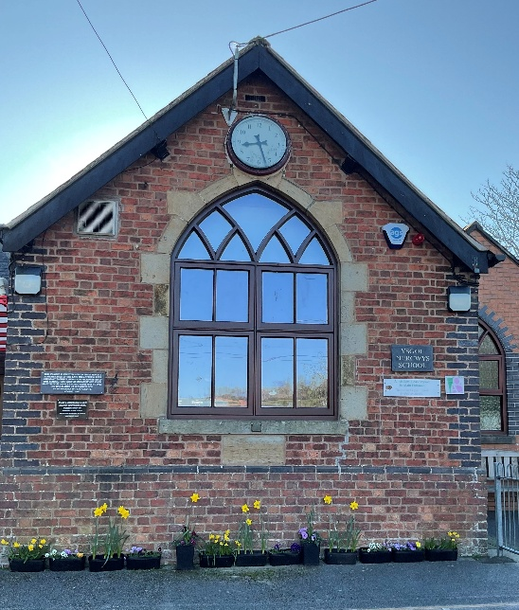
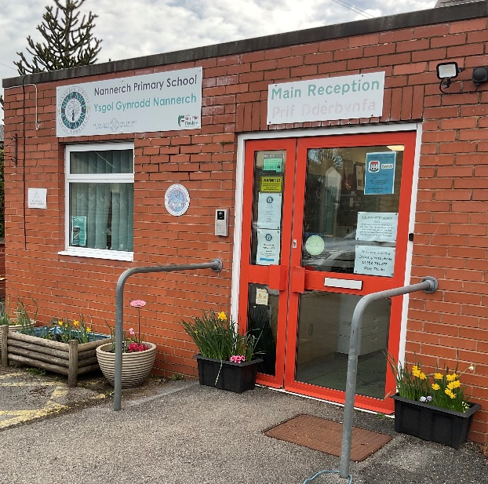


Dear Families,

As we reach the Easter break, it’s wonderful to reflect on a term filled with change and new growth. We’ve journeyed from snowy January mornings to bright March sunshine, watched nature wake up around us, and seen the children grow, develop, and progress in so many exciting ways. This term is always my favourite for exactly these reasons—the sense of renewal, transformation, and the joy that comes with watching our pupils flourish.

Staffing news

This week we say a very reluctant goodbye to Miss Davies at Nercwys. Her care, compassion and dedication have shone through in everything she has done at Nercwys. She has made a lasting impression on the children. She will be greatly missed by the whole school community. We wish her all the best for the future.

Mrs Foster’s Welsh sabbatical comes to an end, and she will return to the federation after Easter teaching in Ysgol Nercwys. One of the benefits of being a federation is the sharing of staff skills across the two schools to the benefit of the children. Therefore, Mrs Foster will spend some time each week at Nannerch this term starting with Thursdays in Miss Roberts class.
Mrs Styles and Miss Roberts will be the teachers on site at Nercwys on Thursdays, providing continuity for the children there. No doubt there will be lots of singing and creativity with Mrs Styles on Thursdays at Nercwys which all the children enjoy immensely.

School Buildings
Nannerch
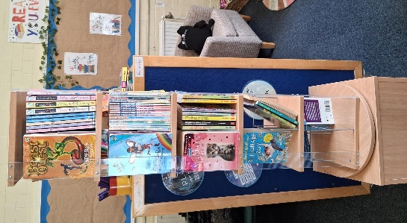
We are thrilled with our brand-new rotating bookshelf for the library. We do still have lots of books in the corridor which we plan to move into the library area. We are looking for smaller shelving for both the library and the junior classroom. We would be very grateful of any donations of any used, good quality bookcases. Please spread the word!

As mentioned last time, we have been advised to improve the security of Nannerch school site in order to keep our school community safe. Therefore, we will be installing a new fence along the perimeter wall that runs parallel with School Lane including two new gates. The safety of our children is of paramount importance and therefore we must proceed with this work. We really enjoy chatting with families at the end of the day. Please use the bottom playground at pick up times where you can wait safely inside the school grounds rather than along school lane.

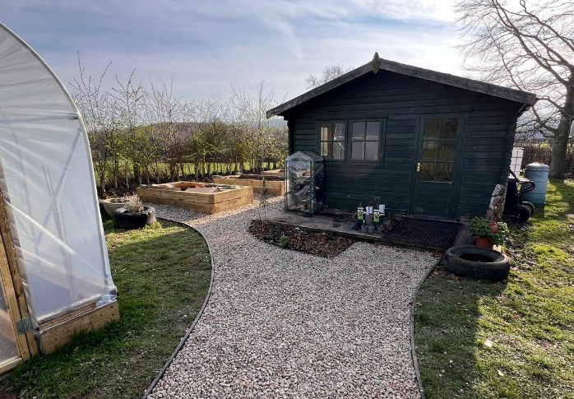
The garden area at Nannerch is now looking fantastic. Thank you to Mrs Rayner for securing grant funding to work with ‘Keep Wales Tidy’ on this project. The transformation is tremendous. We plan for this area to be a community garden, used by and for the local community. Please speak to Mrs Rayner for further details of how to get involved.

The trim trail – good news! We have been successful in securing a small grant to contribute towards costs of repairing or replacing parts of the trim trail which are now unsuitable for use due to age. We hope to secure further donations and along with recent fundraising events, we should be in a position to proceed with this work in the summer.

Nercwys

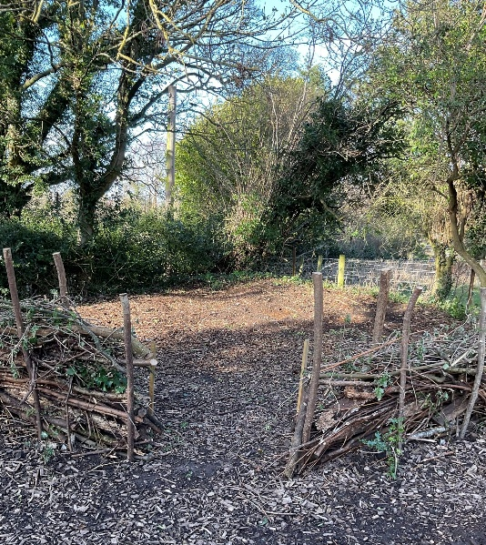
The garden area – We have been successful in securing the support of North Wales Wildlife Trust to work with us on making improvements to the veg patch and garden area. Work has already begun on creating a designated forest school area for the children as well as planting fruit trees and repairing the planters. Thank you to Mrs Yeardley for putting us in touch with the trust. Mrs Foster, who has her own allotment, already has raspberry seedlings ready to go and all staff are eager to get planting!

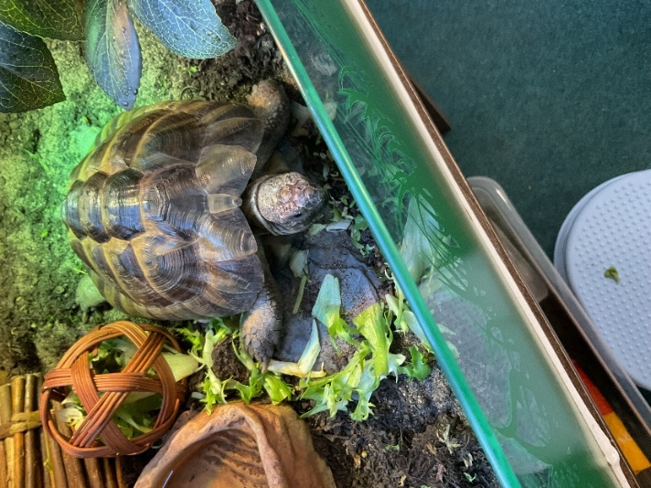
Turbo
Nercwys children were in for a surprise when they returned to school after the February half term. Mrs Styles presented the children with their very own school pet – meet Turbo the tortoise! The children have taken on the responsibility of looking after Turbo during term time and are doing an excellent job- he really is spoilt. Turbo will go home with Mrs Styles during the holidays to spend time with her own tortoise, Benny.
A huge thank you to Mrs Styles for finding Turbo and arranging all of his care for the children.

Worship Council

The Worship council at both schools meet regularly and discuss the value of the half term. Our Christian values are key drivers for our work, and we reflect on these regularly in collective worship. The council have planned themed events each half term to link in with the values for example a craft activity for hope, a cake sale for wisdom and the ‘5 in 5’ sponsored challenge for perseverance. Next term we will be working on compassion and community. The council will also be taking the lead working with members of the church community to plan an afternoon of prayer spaces for the summer term. More details of this will follow.

Federation links

We are always looking for ways in which to further strengthen our links across the two schools. We currently do this by attending trips and residentials together as well as sporting competitions and hosting community events together on one site. For the first time, this year the juniors will go swimming together at Mold. Miss Roberts, Miss Cox and Jenny will accompany the children. It will be lovely for them to spend time together regularly each week.
In preparation for residentials, we will also be hosting a series of live ‘Teams’ calls between classes across the two schools. Transportation across the two schools is always a challenge with costs increasing every year, I would like to express my thanks to those parents who volunteer to transport children to and from any event, we simply could not do it without your help and support.

‘The Den’ After School Club at Nannerch

After Easter there will be ‘Pickle Ball’ sessions every Monday in after school club. All children are welcome to take part in this new sport. On Wednesdays, Mr Lewis will be running a singing club. We are incredibly lucky to have such a talented vocalist to teach our children. Mr Lewis will be working with the children, learning songs to be performed at the Community Café event to be held on Saturday June 6th in the village hall.

Maundy Thursday- St Asaph Cathedral- April 2nd

During the Easter holidays, we will be taking a small group of children to the Maundy service at St Asaph Cathedral. This service will be attended by the King and Queen. We are very honoured to have been invited as representatives of local Church in Wales schools. Unfortunately, it is not possible to take all children as we would have liked. We are excited about the possibility of meeting the King and Queen.

Summer Term

The summer term promises to be another busy one, please see the list of ‘dates for your diaries’ attached. Thank you for all your support during this busy term, it really is appreciated.
School reopens to pupils on Monday 13th April 2026.

Mrs Andrea Taylor

