NANTLWYS NEWSLETTER
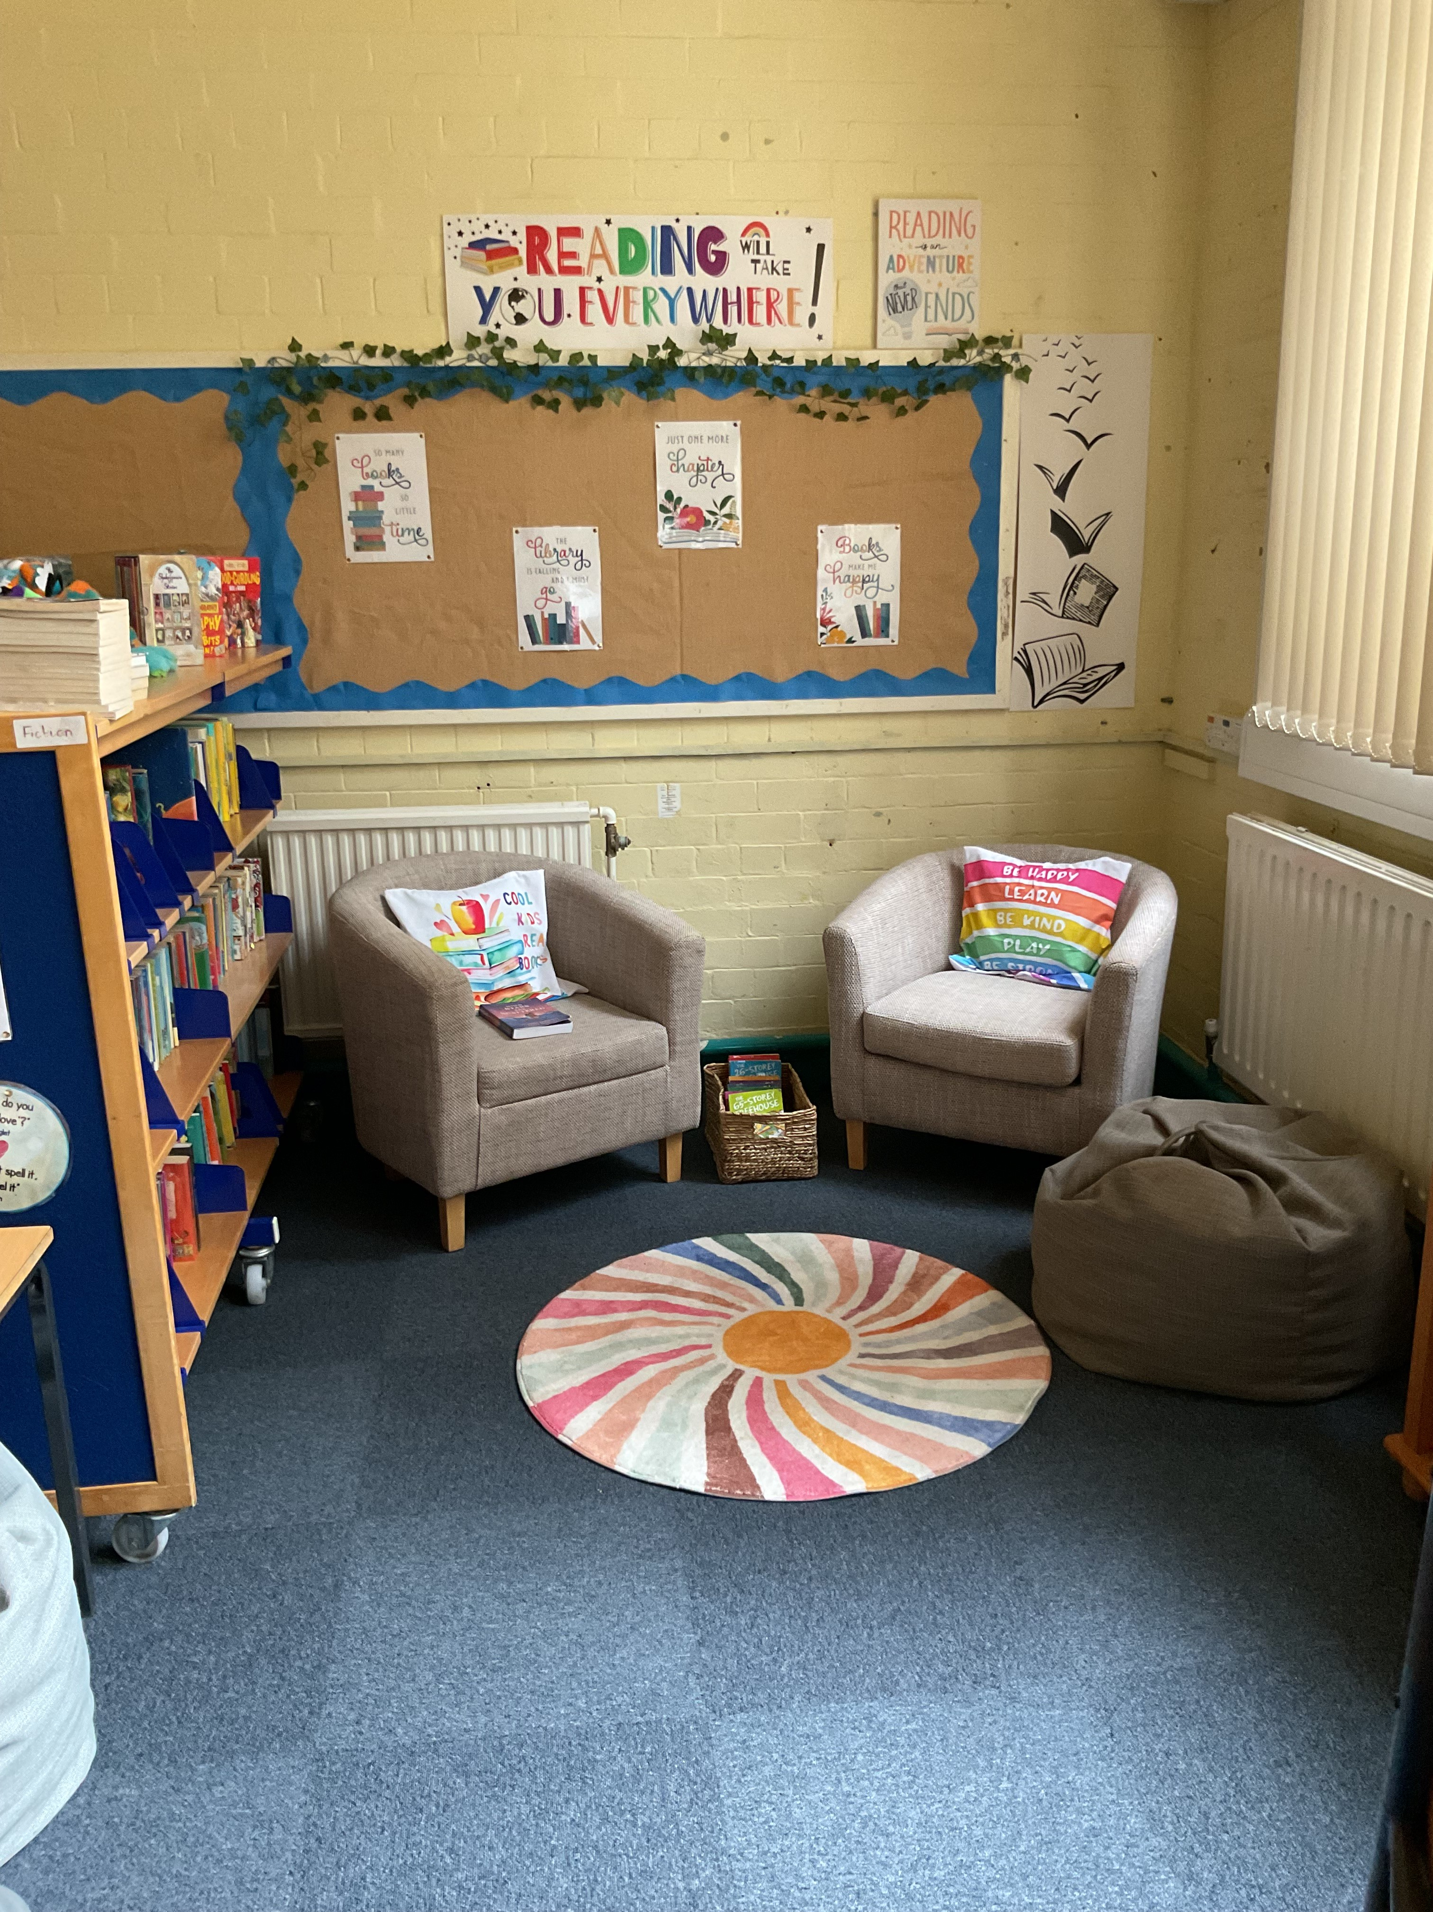
SPRING 2026
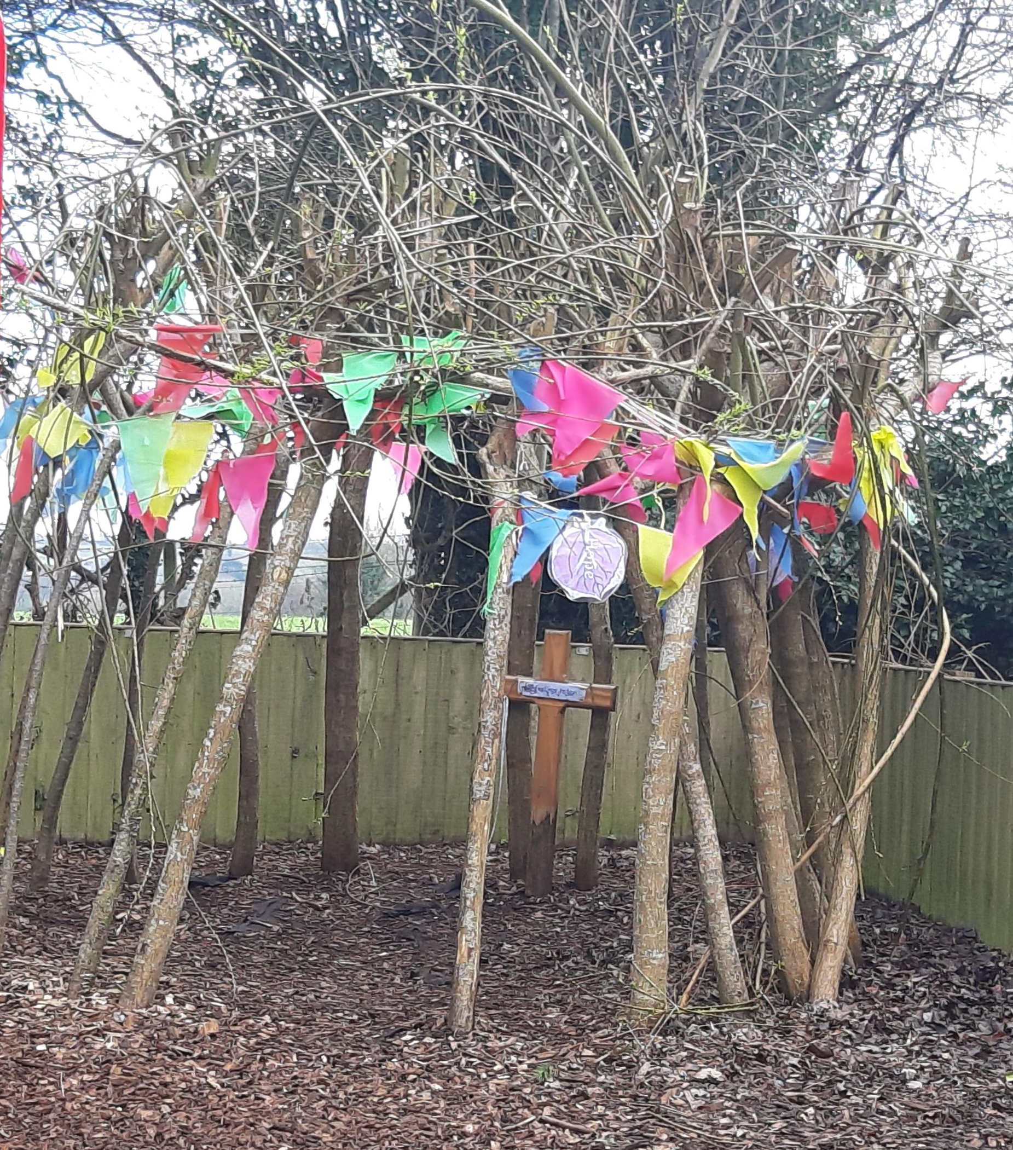
Challenging our Minds
Growing our Hearts

Dear Families,

We are officially halfway through the school year already; can you believe that? Soon the dark evenings will be behind us and we will be able to spend more time outdoors. We are certainly looking forward to feeling the sun on our faces once more.
School reopens to pupils on Monday 23rd February 2026

Staffing news

We are delighted to have Miss Roberts back with us as class teacher, Deputy Headteacher and ALNCO for the federation. Mrs Foster will return full time after the Easter holidays, teaching at Nercwys. She has already agreed to accompany the children and Miss Cox on the London residential in April. Mrs Gunes has also returned to work and we thank Mrs Gibbons for providing excellent care and support for the children this term.

School Buildings
Nannerch
We are thrilled to have been able to obtain a brand-new rotating bookshelf for the library at Nannerch by ‘Excell’ Supply company. We have had a site security visit at Nannerch and have been advised to install more fencing around the school perimeter. We are currently in the process of obtaining quotes for the work and will keep you informed of developments.

Keep Wales Tidy
Thanks to Mrs Rayner for securing the grant and all the resources to improve the garden area. The children will be working in teams on Thursdays to help transform the area. We have raised planters, wild meadow turf, water butts, fruit trees and much more. It is a fantastic project, and the children are enjoying getting muddy in the process.

Nercwys
We are hoping to have some of the fencing around the garden area replaced and again are in the process of obtaining quotes for works. The Diocese are exploring options to repair and restore the Old School House which is attached to the school building. We anticipate that any major works to this will take place during school holidays. We are hoping to work with ‘North Wales Wildlife Trust’ on improvements to our gardening and outdoor area after Easter. Our planters are now in need of replacement, and we are hoping to obtain some grant funding to do this.

Next half term

We will be celebrating Welsh Week during the first week back. All children have taken home a flyer explaining the art and craft homework we hope they will complete over half term. This work will be judged at our Eisteddfod in school on Friday 27th. To celebrate World Book Day, we will be inviting children to come dressed as their favourite book character on Friday 6th March in exchange for Easter egg donations for our Easter Bingo. Parents evenings will be held on March 10th for Nercwys and March 10th and 11th for Nannerch. There will be Easter Bingo at Nannerch on March 18th and at Nercwys on March 19th. Everyone is invited to Bingo.
Easter services at church will take place on March 24th in the morning for Nercwys, everyone is invited. At Nannerch, Easter service will take place on March 26th in the afternoon.

Growing our Hearts

We have been talking about our school mission statement with the children in assembly and together we planned a ‘Growing our Hearts’ cake sale. The children would like the proceeds to go towards supporting after-school club activities. Thank you to everyone who came and supported these events.

Children’s voice

As small schools, the children have regular opportunities to share their views, wishes and ideas. We do also have Criw Cymraeg, School council and Worship council at both schools. The Worship council meet and discuss ways to celebrate and explore our values each half term. This half term we have focused on Wisdom and how we can use our Wisdom to help. For example, at Nannerch, the children used their wisdom to improve the school grounds by weeding and planting at the front of the school. All children across the federation took a short survey and the school council have met to discuss the results. At Nercwys, children have taken part in ‘Well-being Wednesday’ with yoga, mindfulness and circle time KiVa sessions. At Nannerch, the children wanted more ways to tell staff if they were feeling sad or upset. The school council have re-introduced the Worry Monsters to each class with all children having a lolly pop stick with their name on. If someone has any worries, they put their stick discreetly into the worry monster as a sign that they would like to speak to a member of staff. I’m always impressed with the children’s attitudes, compassion for each other and brilliant ideas!

Don’t forget, all children are invited to the after-school football sessions taking place on Wednesdays at Nannerch. We would love to see some of the Nercwys children there and are happy for children to be collected earlier on that day to allow time to travel over to Nannerch.

Wishing you all a wonderful half term break

Mrs Andrea Taylor

