NANTLWYS NEWSLETTER
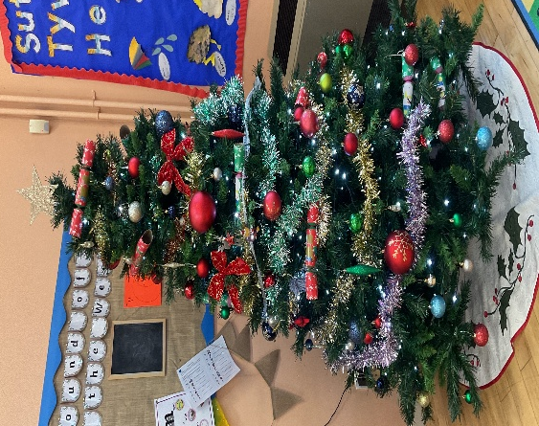
December 2025

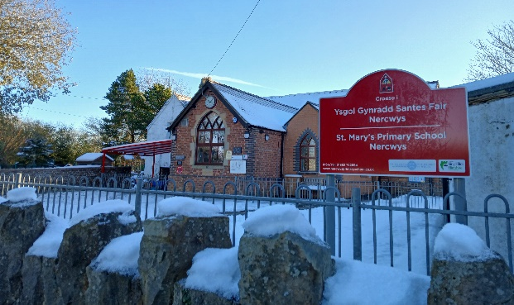
Challenging Our Minds
Growing Our Hearts

Dear Families,

As we reach the end of the autumn term, I want to take a moment to celebrate the incredible hard work and achievements of all our children. Their enthusiasm and dedication have shone through in every lesson and activity. We are also deeply grateful to our families for their continued support and encouragement—it truly makes a difference. This term has been filled with wonderful community events that have brought us all together, such as Harvest celebrations, class assemblies, the federation disco and Christmas Fair and we thank everyone who contributed to making them such a success. We look forward to building on this spirit of teamwork and celebration as we head into the new year!
School reopens to pupils on Tuesday 6th January 2026

Staffing news

We are looking forward to welcoming Miss Roberts back to the federation in January. Miss Roberts returns to her role of Deputy Headteacher and Additional Needs Co-ordinator (ALNCo) for the federation and will be teaching in Dosbarth Nant Ddraig at Nannerch. Miss Roberts will spend some time at Nercwys each week and will continue to be available to support ALN children and families across both schools.

We will say our final farewell to Mrs Davies on Thursday 18th December at our bacon butty morning at Nannerch, and thank her for all her work and support this year. She will be missed!

Finally, we say a fond and reluctant goodbye to Miss Hughes at Nannerch. Her energy and care have made a lasting impact, and the children will miss her greatly. We wish her every success in the future and thank her for everything she has given to our school this term. Pob lwc!

School Uniform
A gentle reminder that leggings, jogging bottoms, shorts and hoodies should only be worn on PE and outdoor days. Short trousers may be worn in the warmer weather. Items can be with or without the school logo but please can all items be clearly labelled with your child’s name.
PE and outdoor days will be shared by class teachers via Seesaw at the start of term.

Christmas at the Nantlwys Federation

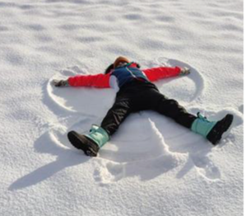
At Nercwys: we made items to sell at the Christmas fair, took part in a concert at the Church, enjoyed Christmas dinner in our jumpers, decorated a tree for the village competition, had a party day and went to Theatre Clwyd to watch the pantomime! Phew

At Nannerch: we took part in a concert at the Church, made items, games and hosted the Christmas fair, enjoyed Christmas dinner in our jumpers, had a party day and went to Theatre Clwyd to watch the pantomime! Wow

Governors
We have welcomed three new governors to the Nantlwys Federation this academic year. Miss Jodie Biddle, (Ada’s mum) and Mrs Kerry Parry (Clara’s mum) have joined the governing body as parent governors. Mrs Jennie Downes has also joined the governors as a Local Authority representative. All three bring expertise to our federation and have already made valuable contributions this term. Mr Ian Roberts has been re-elected as Chair of Governors with Mrs Cath Yeardley as Vice Chair.

Next term
Next term the children will be working on the theme of the natural world and living things and focusing on our values of wisdom and perseverance. The juniors at Nannerch will begin their weekly music lessons through Theatre Clwyd and will be learning to play the pea buzz instrument. We will be celebrating ‘Santes Dwynwen’ day in school on January 23rd and will be celebrating St David’s day during Welsh week as well as holding an Easter service in church. Please see the dates for your diary sheet for a full list of upcoming events next half term.

Winter Weather
As the colder weather approaches, a reminder that any school closures will be shared on Flintshire Council School Closures webpage first. School will then endeavour to send messages to all parents via school coms or email. In extreme bad weather, the decision to close after school club early and open breakfast club later may also be taken in order to ensure safety of all accessing the school site. We kindly ask for your support in this matter.

PTA

We are very keen to develop our PTA to help support with fundraising events. If you would like to get involved, please let Mrs Taylor or Miss Roberts know.

New look Website
Our new look website is now live. We hope that you will find this more user friendly. The website will be updated with newsletters, photographs and upcoming dates. The web address remains the same https://www.nantlwysfederation.com/

And finally, sending you love, joy, and God’s blessings this Christmas season.



Nadolig Llawen

Mrs Andrea Taylor

