NANTLWYS NEWSLETTER
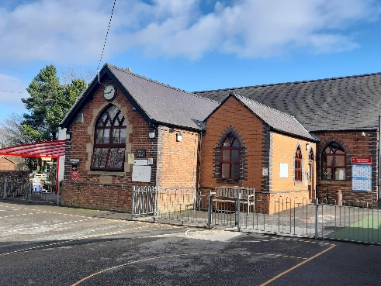
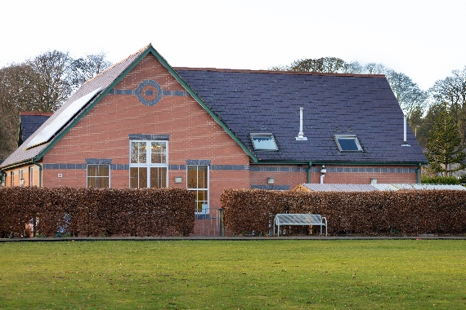
Autumn 2025
Challenging Our Minds
Growing Our Hearts
Dear Families,

We have come to the end of our first half term which is always a busy time. The children are now established into their new routines and classes, and it is lovely to see their enthusiasm for learning growing every day. This term the children have been learning about ‘Stories that Shape Us’. We have celebrated Harvest and will soon begin to turn our attention towards Advent and Christmas.

Website
Our new-look website will be launching in December. Please keep an eye out for this which we hope will prove more attractive, useful and user-friendly. The web address remains the same www.thenantlwysfederation.com

Attendance
Attendance letters will be sent out shortly for your child’s attendance for this half term. We appreciate that some children’s attendance has dropped below the 90% marker and that some of this is due to holidays and the many bugs going around at thit time of year. We anticipate that attendance levels will rise next term. Please speak to us if you have any concerns.

Upcoming events
Nannerch Open Afternoon – November 7th at 2pm for any new Nursery or Reception children.
Parents evenings – Nercwys Tuesday 11th November, Nannerch 11th and 12th November
Nercwys class assembly 13th November at 9:15 all welcome
Years 3-6 to visit St Asaph Cathedral on 17th November
Nannerch class assembly for Years 3-6 November 19th at 9:15 in school, all welcome
Nercwys Open Afternoon – November 20th at 2pm for any new Nursery or Reception children
Years 5 & 6 to visit the Alun school all day on November 27th (transport provided)
December 3rd – Explore workshops at school for Years 3-6 – Free!
December 4th – Federation Christmas Fair after school at Nannerch
December 10th – Nannerch Christmas concert at Church, 2pm and 5pm
December 11th – Nercwys Christmas concert at Church at 5pm
December 17th – Panto at Theatre Clwyd

School Improvement Journey

This year we have set the following areas as priorities for our school improvement:
- To continue to raise standards in mathematics through consistent, high-quality teaching
- To raise standards in writing
- To further develop the wellbeing of all pupils through ensuring a sense of belonging within the Christian community.

Fundraising
Thank you for all your support with our fundraising efforts. So far money raised has been spent on the following:
- Creating a new library area in the hub room at Nannerch ( we are still looking for an additional bookshelf, if anyone has one they no longer need and can drop it off at school please let us know!)
- Refurbishing the nurture rooms at both schools including painting at Nercwys
- Brand new play equipment for play times at both schools
- Treats for Star in the Jar time
- Subsidise the cost of transport for school trips eg trip to the panto

Macmillan Coffee and Cakes

Thank you to everyone who came along at both schools. Ysgol Nannerch raised £250 and Ysgol Nercwys raised £145.
Grant applications and projects

We continue to apply for grant funding to support further improvements to our school grounds at both sites. We are currently awaiting a decision on a grant for new trim trail at Nannerch and will be applying for funding for new fencing and nature resources for the garden at Nercwys.

Some highlights from this term
Apple pressing Making our own cordial ‘Cobweb Crumble’

The Den Diner at Ysgol Nannerch ‘Rock Band’ workshop at Nercwys Learning CPR skills

Mrs A Taylor

